**LAPORAN ACTIVITY**

Mata Praktikum : Perancangan Analisis Algoritma

Kelas : 3IA24

Praktikum ke- : 1

Tanggal : 20 Oktober 2023

Materi : Algoritma Greedy

NPM : 50421704

Nama : Juan Samuel Christopher

Ketua Asisten : Sherina Permata

Nama Asisten :

Paraf Asisten :

Jumlah Lembar : 3



**LABORATORIUM TEKNIK INFORMATIKA**

**UNIVERSITAS GUNADARMA**

**2023**

**SOAL**

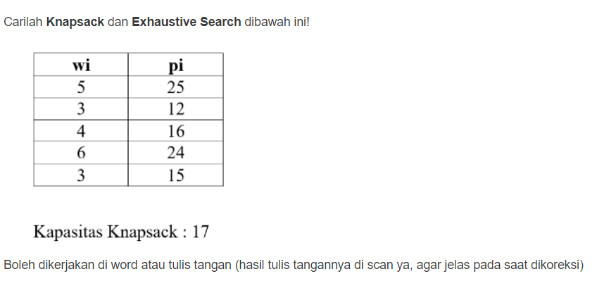

**Jawab**

1. **Knapsack Search**

|  |  |  |  |  |  |  |  |
| --- | --- | --- | --- | --- | --- | --- | --- |
| **PROPERTI OBJEK** | | | | **GREEDY BY** | | | **SOLUSI OPTIMAL** |
| **i** | **wi** | **pi** | **pi/wi** | **Profit** | **Weight** | **Density** |
| **1** | **5** | **25** | **5** | **1** | **1** | **1** | **1** |
| **2** | **3** | **12** | **4** | **0** | **1** | **1** | **1** |
| **3** | **4** | **16** | **4** | **1** | **1** | **1** | **1** |
| **4** | **6** | **24** | **4** | **1** | **0** | **0** | **0** |
| **5** | **3** | **15** | **5** | **0** | **1** | **1** | **1** |
| **Total Bobot** | | | | **15** | **15** | **15** | **15** |
| **Total Keuntungan** | | | | **65** | **68** | **68** | **68** |

1. **Exhaustive Search**

|  |  |  |
| --- | --- | --- |
| **HIMPUNAN BAGIAN** | **TOTAL BOBOT** | **TOTAL KEUNTUNGAN** |
| **{1}** | **5** | **25** |
| **{2}** | **3** | **12** |
| **{3}** | **4** | **16** |
| **{4}** | **6** | **24** |
| **{5}** | **3** | **15** |
| **{1,2}** | **8** | **37** |
| **{1,3}** | **9** | **41** |
| **{1,4}** | **11** | **49** |
| **{1,5}** | **8** | **40** |
| **{2.3}** | **7** | **28** |
| **{2,4}** | **9** | **36** |
| **{2,5}** | **6** | **27** |
| **{3,4}** | **10** | **40** |
| **{3,5}** | **7** | **31** |
| **{4,5}** | **9** | **39** |
| **{1,2,3}** | **12** | **53** |
| **{1,2,4}** | **14** | **61** |
| **{1,2,5}** | **11** | **52** |
| **{1,3,4}** | **15** | **65** |
| **{1,3,5}** | **12** | **56** |
| **{1,4,5}** | **14** | **64** |
| **{2,3,4}** | **13** | **52** |
| **{2,3,5}** | **10** | **43** |
| **{2,4,5}** | **12** | **51** |
| **{3,4,5}** | **13** | **55** |
| **{1,2,3,4}** | **17** | **77** |
| **{1,2,3,5}** | **15** | **68** |
| **{1,2,4,5}** | **16** | **76** |
| **{1,3,4,5}** | **18** | **0** |
| **{2,3,4,5}** | **16** | **67** |
| **{1,2,3,4,5}** | **21** | **0** |
| **OPTIMAL** | **15** | **68** |